Mentor Guide February 2025

Reminder: Please set healthy boundaries with your mentees. Also, please be sure to engage and share, as your energy and willingness to be present sets the vibe for the meeting.
- Ice Breaker
- What is something you have always wanted to learn or try?
- You both share something personal, something professional and something peculiar. Please share at each of your own comfort level. You can skip one of the parts if you don’t have anything you would like to share.
- How have you been? Anything that is timely or important to you that you would like to talk about?
- Let's talk about having a strong professional image out there
- Do you use LinkedIn?
- Let's take a look and open it up together if you have it, if not, would you be interested in creating one?
- Important things to note:
- Profile picture
- This is the first impression people see when they view your profile
- Make sure it is a clear photo, preferably with just you so people you have met, will recognize you better
- Title
- Some ideas for what you can put in the field: industry you are interested in, your current job title, what degree you are working on, etc.
- Previous positions
- Previous positions can show your levels of experience in a field and what you have accomplished
- Education
- Put any prior or current education
- Certificates
- If you have any certifications or licenses, be sure to include them as this can be helpful for employers viewing your profile
- Skills
- Any skills you have such as public speaking, presentations, etc. Can be included here. You can look up skills that are useful in your industry as well, to see things potential employers view as useful for positions you are interested in
- Do you utilize the app often to grow your network?
- Continue to do informational interviews and this can also expand your professional network to new depths
- Connections can help you in current positions, but also future positions
- Are you ready to give an “elevator pitch”
- When you meet someone, do you have a 1–2-minute introduction that tells them who you are and what you are interested in?
- Allows you to be ready to give a short introduction. This will help you network with people or if you are introudced to someone unexpectedly
- Let’s practice. Introduce yourself as if I am a stranger at the workplace
- Have you done any mock interviews?
- Mock interviews can transform your answers
- Have you ever had a scenario that you played out in your head and then when you said it out loud it didn’t come out the same?
- Mock interviews help you strengthen your answers, your confidence and remind you of the importance of pacing in an interview
- Have you ever visited career services?

Students wishing to withdraw from a course can use the Withdrawal Request Online Form. Students looking to withdraw from a course or from the semester will need to submit the online form. The Withdrawal Request Online Form will be available for students to submit until the last day of semester they are requesting to withdraw from.

- Location - the form is located right below “Course Registration Request Form” on Registrar page in The Q. The student must log into The Q to access this form.
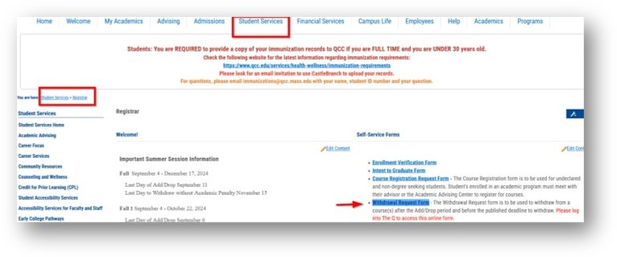
- Functionality - this form allows students to request to withdraw from an individual course (i.e. ENG 101, MAT 123) by selecting each course individually from the drop-down OR all classes from a semester by selecting “I wish to withdraw from ALL enrolled courses for this semester.” option.
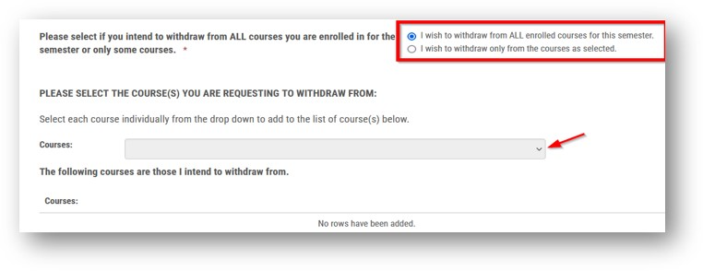
- Workflow

- Registrar’s Office

- After the Add/Drop period and before the published deadline to withdraw from a course with a “W” grade (through the 10th week or equivalent)
- Once the form is submitted, Registrar’s office will process as a course withdrawal with a grade of “W” within 24-48 business hours.
- Email (Reply All) to the group including a student who is also copied on the email to notify and let them know that the withdrawal request has been officially processed in system.
- Save the Withdraw Request Form in Perceptive Content

- After the published deadline to withdraw without Academic Penalty (after the 10th week of class)
- Once a form is submitted, Registrar’s office will forward the withdrawal request to the instructor(s) to assign a grade of “W” or “F” for a course.
- Once we receive a grade confirmation (“W” or “F”) from an instructor, Registrar’s office will process accordingly, and save the email in Perceptive Content.
- It is important that faculty member respond to the email in a timely manner
- Please remember that a withdrawal request must be initiated by the student

